New product price strategies are critical to set before your new product launch.
How are prices set? In the past, price strategies for new products were set by buyers and sellers negotiating with each other. Your price strategies in marketing and associated marketing channels are critical to your success.
Sellers would ask for a higher price than they expected to receive, and buyers would offer less then they expected to pay. Through bargaining, they would arrive at an acceptable price.

What is price strategies for new products?
New products were developed, and the market for watches gained a reputation for innovation. The diagram depicts four key pricing strategies, namely premium pricing, penetration pricing, economy pricing, and price skimming, which are the four central pricing policies and strategies.
The strategic importance of price demonstrates how products, distribution, price, and promotion strategies will fit together into an integrated strategy of program positioning.
Analyzing the pricing situation is necessary to develop a price strategy for a new product mix or new product line, or to select a price strategy for a new product or brand.
Underlying strategy formulation is several important strategic activities, including analysis of the product market, cost, competition, and legal and ethical considerations.
As you move to a product launch or just adjusting your pricing, you should begin to determine how it will affect your leads and sales. This handy marketing funnel and leads calculator will help.

How Many Leads Do You Need to Reach Your Sales Goals?
Calculate How Many Leads You Need to Rea

Pricing is a problem when a company has to set a price for the first time.
This happens when:
- The company develops or acquires a new product
- When it introduces its regular product into a new distribution channel or geographical area
- When it enters bids on new contract work

Key Marketing Metrics Your CEO Cares About.

Use this marketing scorecard toolkit to bring structure and meaning to your numbers.
Analysis of the pricing situation provides useful information for the pricing of new products.
Additional considerations in deciding about prices include:
- Determining price flexibility
- Deciding how to position price relative to the cost
- Deciding how visible to make the price of the new products
- Establishing price policies and structure
Pricing approaches for new products include:
- High-active
- High-passive
- Low active
- Low passive strategies
Variations within the four categories occur. The many industries, marketing managers establish prices that are followed by other companies in the industry.
Several special pricing considerations include price segmentation, distribution channel pricing, product lifecycle pricing, and price and quality relationships. The determination of specific prices may be based on cost, competition, and/or demand influences.

The Six-step Procedure for Setting New Product Pricing

The company has to consider many factors in setting its pricing policy. Here’s a quick six-step procedure for setting price pricing for new products.
- Selecting the pricing objectives
- Determine the demand for sales volume
- Estimating cost
- Analyzing competitors price and offers
- Selecting a pricing method
- Selecting the final price point
A good marketing manager will be able to determine the demand, even with the new product activity in the target market.

How Much Flexibility Exists in Pricing New Products?
Demand and cost aspects determine the extent of price flexibility. Within these upper and lower boundaries, competition, among the legal and ethical considerations, may influence the choice of a specific price strategy.
Exhibit 1 illustrates how these factors determine flexibility. The flexibility range for a price between demand and cost may be narrow or wide. A narrow gap simplifies the decision, a wide gap suggests a greater range of visible strategies.
How Much Flexibility Exists in Pricing New Products?CLICK TO TWEET
The choice of a price strategy within the gap is influenced by competitive strategies, future, and present, and by legal and ethical considerations. Management must determine where the price within the gap shown in Exhibit 1.
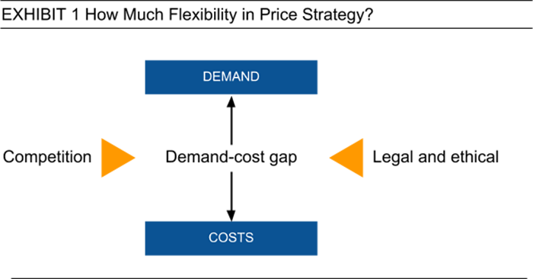
In competitive markets, the feasibility range may be very narrow. New markets are emerging market segments in established markets that may allow our firm substantial flexibility in strategy selection.
The price band for a product indicates the amount of flexibility and pricing compared to the competition.
It is a function of:
- Competitive intensity
- The value of the brand as perceived by buyers
Commodity type brands have a narrow price band. Since buyers consider all commodity brands to be equivalent, they will move to the lowest price offered for a commodity item.

Price Positioning and Visibility
A key decision and how high to price a new product within the flexibility band. Companies can charge a relatively low entry price with the objective of building volume and market position or set a high price to generate large margins.
The price strategies for new products help product positioning.
The former is a penetration strategy whereas the latter is a price skimming strategy. A lack of knowledge about previous market responses to the new product complicates the pricing decision.
Several factors may affect the choice of a pricing approach for a new product, including:
- The cost and the estimated lifespan of the product
- The estimated responsiveness of buyers to alternative prices
- Assessment of competitive reactions
A decision should also be made about how visible the price will be in the promotion of the new product. The use of a low entry price requires active promotion of the price to gain market position.
A lack of knowledge about previous market responses to the new product complicates the pricing decision.CLICK TO TWEET
When companies use a higher price relative to cost, the price often assumes a passive role in the marketing of the new product and market penetration. Instead, the performance and other attributes of the product are stressed in the marketing program positioning strategy.

Price Policy and Price Structure
Determining your price flexibility, positioning price against the competition, and deciding how to activate the marketing component will be in the marketing program.
This does not establish the operating guidelines necessary for implementing a price strategy. It is necessary to also determine policies and price structure.
Price strategies for new products need a price policy and structure in more complex product offerings.
Price is a focal point of the company’s positioning strategy. Anytime more than one product is involved, the company must determine product mix and line pricing into relationships in order to establish a price structure.
Determining your price flexibility, positioning price against the competition, and deciding how to activate marketing component will be in the marketing program.CLICK TO TWEET
And when more than one target market is involved, the relationships exist between the products offered in each? Assuming a difference in products, should the price be based on cost, the demand, or competition?
Price structure considers how individual items in the product line are priced in relationship to one another. The item may be aimed at the same target market or different and user groups.

For example, department stores often offer economy or premium product categories. In the case of a single product market, price differences among products typically reflect more than variations in the cost.
Large supermarket chains price for the total profitability of the product offering rather than for the performance of individual items.
These retailers have developed computer analysis and pricing procedures to achieve sales, market share, economies of scale, and profit objectives.
Once product relationships are established, some basis for determining price structure must be selected. Many firms base price structure on market and competitive factors as well as differences in the cost of making each item.
Some use multiple criteria for determining price structure and have sophisticated computer models to examine alternative pricing schemes.
The following guidelines are used in pricing a product line:
- Price each product in relation to all others, noticeable differences in products should be equivalent to perceive value differences
- The top and bottom prices in the line should be priced to foster desired buyer perceptions
- Price differences between products should become larger as price increases over the product line
Most approaches include not only cost considerations but also demand and competitive concerns. For example, an industrial equipment manufacturer sometimes prices new products at or close to cost.
And depend on sales of high-margin items such as supplies, parts, and replacement items to generate profits. The important consideration is to price the entire product mix and product line to achieve price objectives.
Now let’s explore the price strategies in more detail.

Competitive Strategy and Positioning
The choice of a price strategy depends on how management decides to price the product relative to the competition. And whether price performs and an active or passive role in the marketing program.
The use of price as an active or passive factor refers to whether prices discussed in advertising, direct selling, and other promotional efforts.
The strategy is shown in Exhibit 2 to indicate the range of price strategies that companies can use.
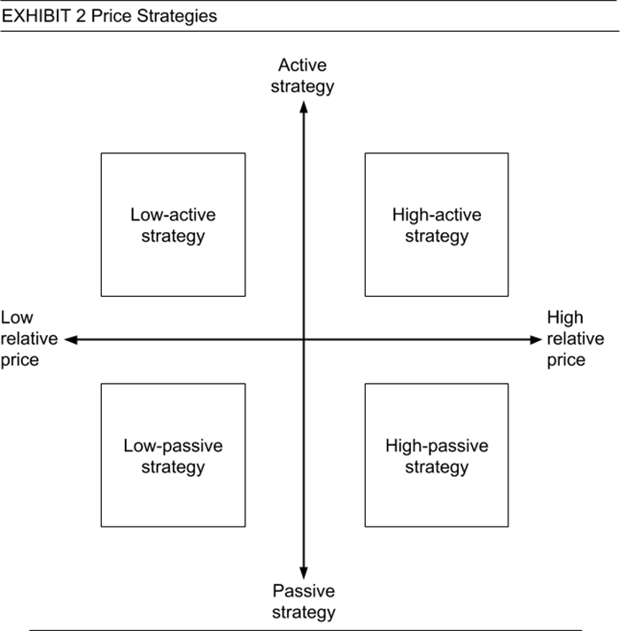
Many companies choose to price at or near the prices of key competitors, and non-price factors are emphasized in their marketing strategies.
New product price strategies are critical before a product launch.CLICK TO TWEET

High Active Strategy
This strategy is sometimes used for prestige brands seeking an affluent image. These companies can charge a premium price. When the buyer cannot easily evaluate the quality of a product, the price can serve as a signal of value.
High prices may be essential to gain the margins necessary to serve small target markets, produce high-quality products, or pay for the development of new products.
Making price visible and active can appeal to buyers’ perceptions of the quality, image, and dependability of products and services. A company using a high price strategy is also less subject to retaliation by competitors, particularly if its product can be differentiated.

High Passive Strategy

High price items are more often marketed by featuring non-price factors rather than using highly active strategies. Product features and performance can be stressed when the people in the target market are concerned with product quality and performance.

Low Active Strategy and Price Strategies for New Products
Many retailers use a strategy, including Lowe’s, Dollar General stores, and Payless Shoes. When a price is an important factor in buyers’ decisions, a low active price strategy can be very effective.
However, this strategy may start a price war. And it is a more attractive option when the competition for the target market is not heavy. Or when a company has caused advantages in a strong position in the product market.

Low Passive Strategy
This strategy may be used by manufacturers whose products have low-cost features than other suppliers. By not emphasizing low prices, the company runs less danger that potential buyers will assume the product quality is inferior to other brands.
Some firms participating in conventional channels may not spend much on marketing their products and may offer low prices because of lower costs.
Other companies that have actual cost advantages for comparable competing products may decide to stress value rather than price while offering prices lower than competing brands.

