Meeting Room Set-ups and Styles
Auditorium Style
Appropriate for a short lecture or larger groups that do not require extensive note-taking.

Banquet Style
Used for meals and small group discussions. 5' rounds seat eight people comfortably.

Hollow Square Style
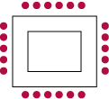
Appropriate for groups fewer than 40 where there is a group leader or panel seated at the head of the set up.

Classroom
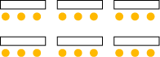
Most desirable for long lectures. For large numbers, tables will need to be rented.

U-Shape Style
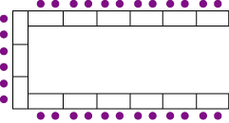

Conference Style
